GlobalSight Upgrade Installer Instructions (for Windows & Ubuntu)

Note: before running the GlobalSight Upgrade Installer, make sure GlobalSight service is stopped and MySQL database is started

For Windows:

- Download and unzip the GlobalSight_Upgrade_Installer_<version>.zip package.

- Double click on the "run.bat"

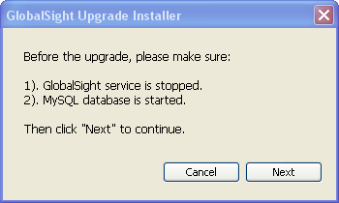

- The GlobalSight Upgrade Installer will look for the installValues.properties file stored in C:\Documents and Settings\<user>\Local Setting\Temp folder to determine the GlobalSight installation directory. If found, it will proceed with upgrade (step 5).
If this file is not found, you will be prompted to manually enter the GlobalSight installation directory.

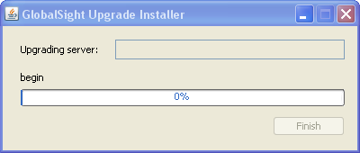

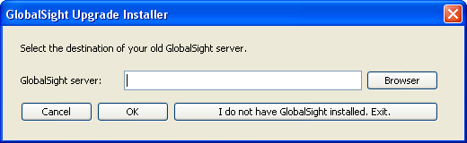

- Enter the GlobalSight installation directory and click "OK".
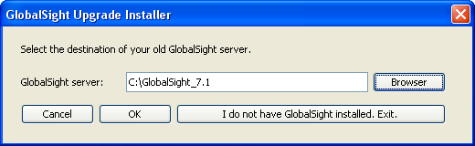

- The GlobalSight Upgrade Installer will backup previous version of GlobalSight and apply the upgrade to your GlobalSight instance. Click "Finish" to exit the installer.
The "backup" is stored in <GlobalSight_Upgrade_Installer_x.x.x.x>\installer\backup folder.

The upgrade log can be found in <GlobalSight_Upgrade_Installer_x.x.x.x>\installer\log.txt

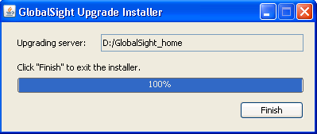

- Re-start GlobalSight Service.

For Ubuntu:

Before doing the GlobalSight upgrade:
- Login to a user with sudo privileges.
- Stop Globalsight: /etc/init.d/globalsight stop
- Make sure MySQL database is running.

- Download and un-jar the GlobalSight_Upgrade_Installer_<version>.zip
Type: jar xvf GlobalSight_Upgrade_Installer_<version>.zip

- Add execute attribute to run.sh
Type: chmod u+x run.sh

- Run the GlobalSight Upgrade Installer
Type: ./run.sh

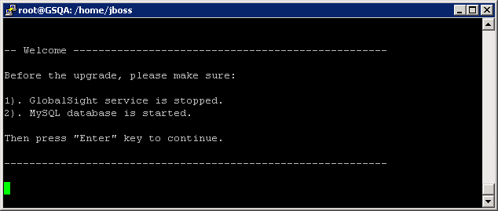

- The GlobalSight Upgrade Installer will look for the installValues.properties file stored in /tmp folder to determine the GlobalSight installation directory. If this file is found, the Upgrade Installer will proceed with upgrade (step 7)
If this file is not found, you will be prompted to manually enter the GlobalSight installation directory.

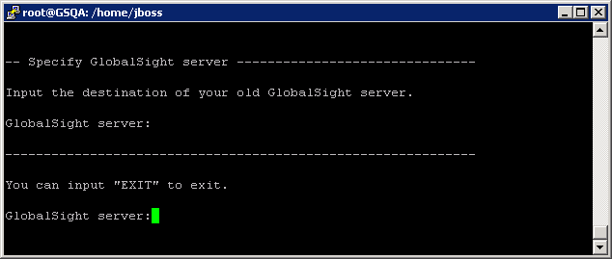

- Enter GlobalSight installation directory and press "Enter" key.
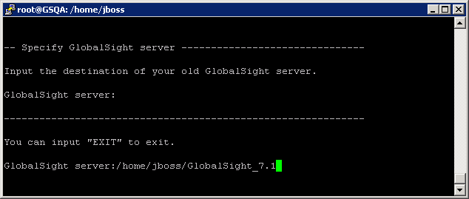

- The GlobalSight Upgrade Installer backup previous version of GlobalSight and apply upgrade to GlobalSight.
The "backup" is stored in <GlobalSight_Upgrade_Installer_x.x.x.x>/installer/backup directory.

The upgrade log can be found in <GlobalSight_Upgrade_Installer_x.x.x.x>/installer/log.txt
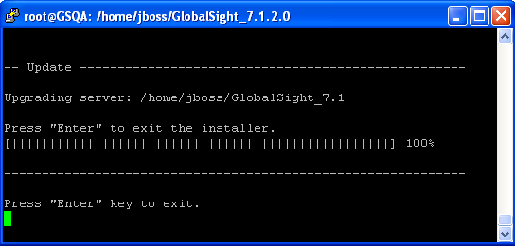

Press "Enter" to exit the installer.

- Re-start the GlobalSight:
Type: /etc/init.d/globalsight start

